
Regular Monthly Meeting
Tuesday, September 19, 2006, 7:30 – 8:30 p.m.
Bayland Community Center, 6400 Bissonnet

Yard of the Month

5821 Grape
___________________________________________________

Help Save Curbside Recycling in
Braeburn Terrace

Neighborhoods with low participation could lose curbside recycling pickup under a plan by the City. The effort is a response to declining participation over the last four years, which saw collected tonnage go down 13 percent citywide.
Four neighborhoods that increase participation or volume the most could receive $5,000.00 rewards. PLEASE RECYCLE! We have until November to show that we are serious about recycling.

DUNLAP CONSTRUCTION PROJECT

This is a brief update on the progress of the Dunlap Street Construction: The project is going slower than anticipated, especially the paving and concrete work. One reason is the rain which is causing continued delays. The wet conditions make it difficult for the contractor to obtain raw materials from suppliers, and to properly cure and pour concrete without creating structural problems with the road and storm sewer inlets.
Over the summer, the 36" water line was installed (west side) between Beechnut and Birdwood. The road pavement has been poured, and they are currently working on completion of intersections and driveways. Installation of the last portion of the 36" water line between Birdwood and Reamer is scheduled next week. After that block is paved, the section north of Beechnut will be paved. They are continuing to complete the remaining storm sewer inlets (boxes), and will finish the pipe connection from Braeswood to Hillcroft following valve placement and testing (unsure of the timeline). The contractor's scheduled timeline is to complete this phase of the project by late September. However, we know that unexpected complications and/or rain could cause additional delays. Nevertheless, we continue to press the contractor, surety and city to finish this project as quickly as possible--- communicating with them frequently and taking our frustrations and concerns to the monthly meetings.
If the work progresses unhampered, we hope to see the curbs, sidewalks, final restoration (landscape) begin later in the fall. In all reality, it could be the holidays before the project is finished. During the remainder of the project, we strongly suggest that each of you who live on Dunlap be directly involved as your driveway, sidewalks, and landscaping work is done. Feel free to call on us to help you get connected with appropriate individuals with the contractor and city as this work is done, or if you have any other concerns you want heard at this time.
Many thanks to Dean Lowry, Gary Teeter, Lynne Zalesak, Bob Fritts, and any others who helped to clean up Dunlap Street on Saturday.

- Mary Hendricks, Dean Lowry, Debi Sterling, 08/27/06
HEAVY TRASH COLLECTION:
Tuesday, September 26, 2006

Placing trash curbside at ANY TIME other than the weekend prior to until the morning of collection day may result in a significant fine. Help keep our neighborhood clean and sanitary! Call 311 to confirm schedule or to report violations. For more information go to:

www.houstonsolidwaste.org.

CURBSIDE RECYCLING DATES:
● September 19 ● October 3 ● October 17

DEED RESTRICTIONS: Braeburn Terrace is a single-family, residential neighborhood with deed restrictions in place to protect the quality of life and property values for home owners and residents living in the subdivision. Be advised that violating deed restrictions in Braeburn Terrace may result in legal action.
Thanks to all of you who participated in this year’s National Night Out block party, our seventh year to have one large block party. We had a great time - snow cones and a gentle mist helped us “keep our cool.”

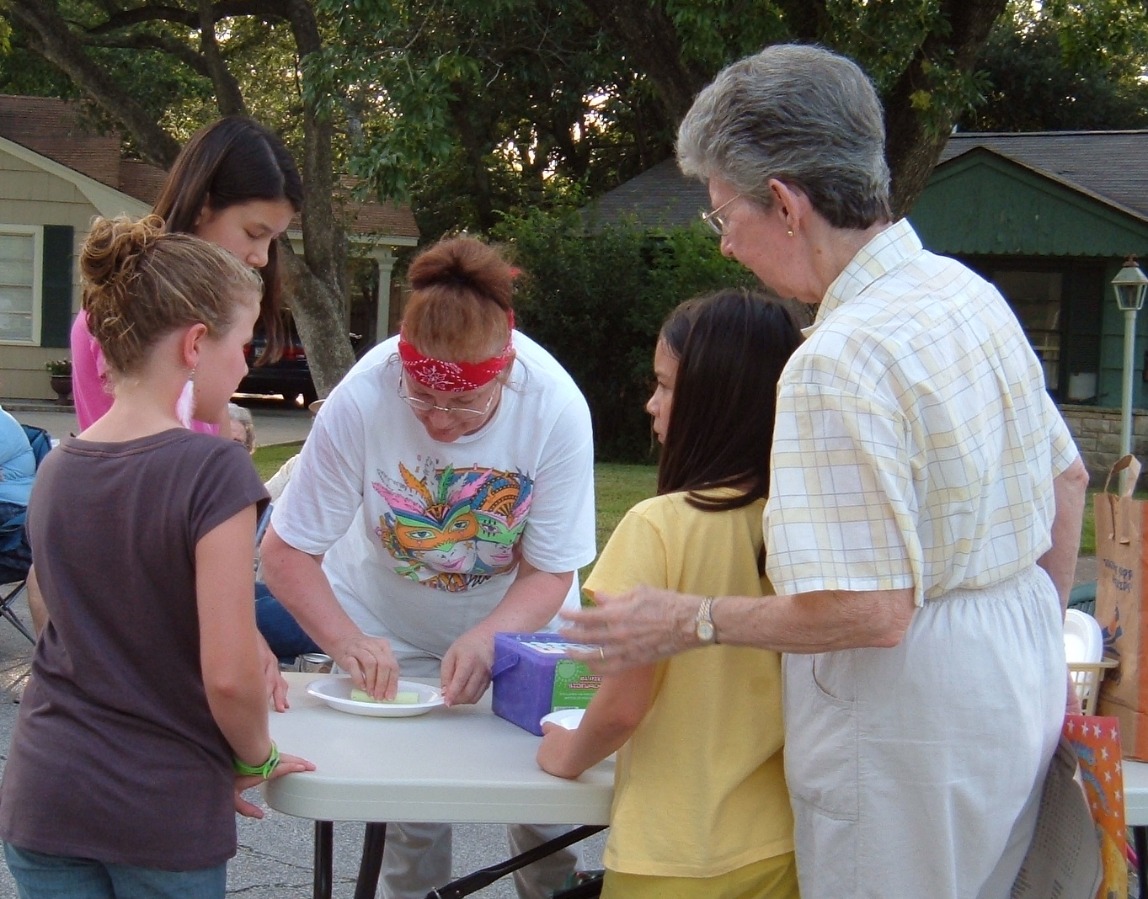
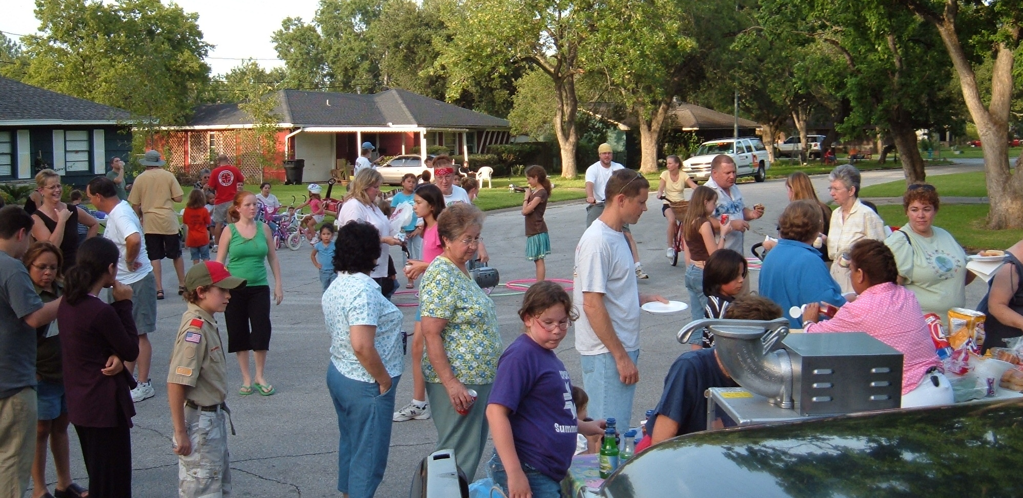
Officers for Fiscal Year July 1, 2006 - June 30, 2007

President: Roger Schuler Directors: Rick Merkl
Vice President: Lori Hanna Mary McGuire
Secretary: Paula Pizzitola Ann Starr
Treasurer: Arturo Romero

Alternate Directors: Kitty Myers Webmaster: Keith Hanna
Lynn Babineaux Newsletter: Ann Starr

TO CONTACT OFFICERS OR DIRECTORS (1) WRITE TO:
Braeburn Terrace Civic Club P.O. Box 2713 Bellaire, TX 77402-2713

OR (2) SEND A MESSAGE TO THE WEBSITE:
Website: BraeburnTerrace.org OR (3) ATTEND A MEETING

Computer repair and upgrades make your computer run faster!
Virus and spyware removal to protect your data and identity theft!
Wireless internet installation and security configuration!
We promise same day to next day service and flat rate pricing!

support@warpspeedpc.com

Chris Watkins
713-471-7169

Houston Police Department
September P.I.P Meeting

CONCERNED ABOUT CRIME? Attend our area’s Positive Interaction Programs on the fourth Tuesday of each month to pick up crime statistics for our area, get to know the officers who patrol our neighborhood, and to learn about relevant topics from the guest speakers.

Tuesday, September 26, 2006, 7:30 pm
Aramco Building Auditorium
9009 West Loop South

The City Wide P.I.P. is the second Tuesday of the month at 1602 State Street. Attend and meet the Chief of Police.

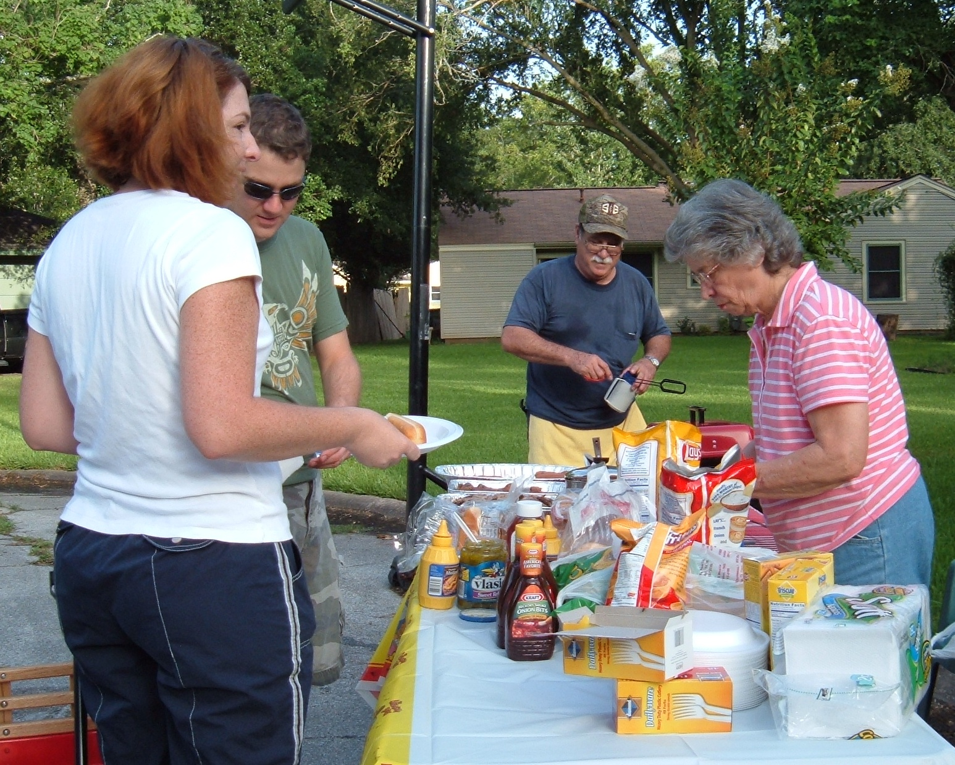
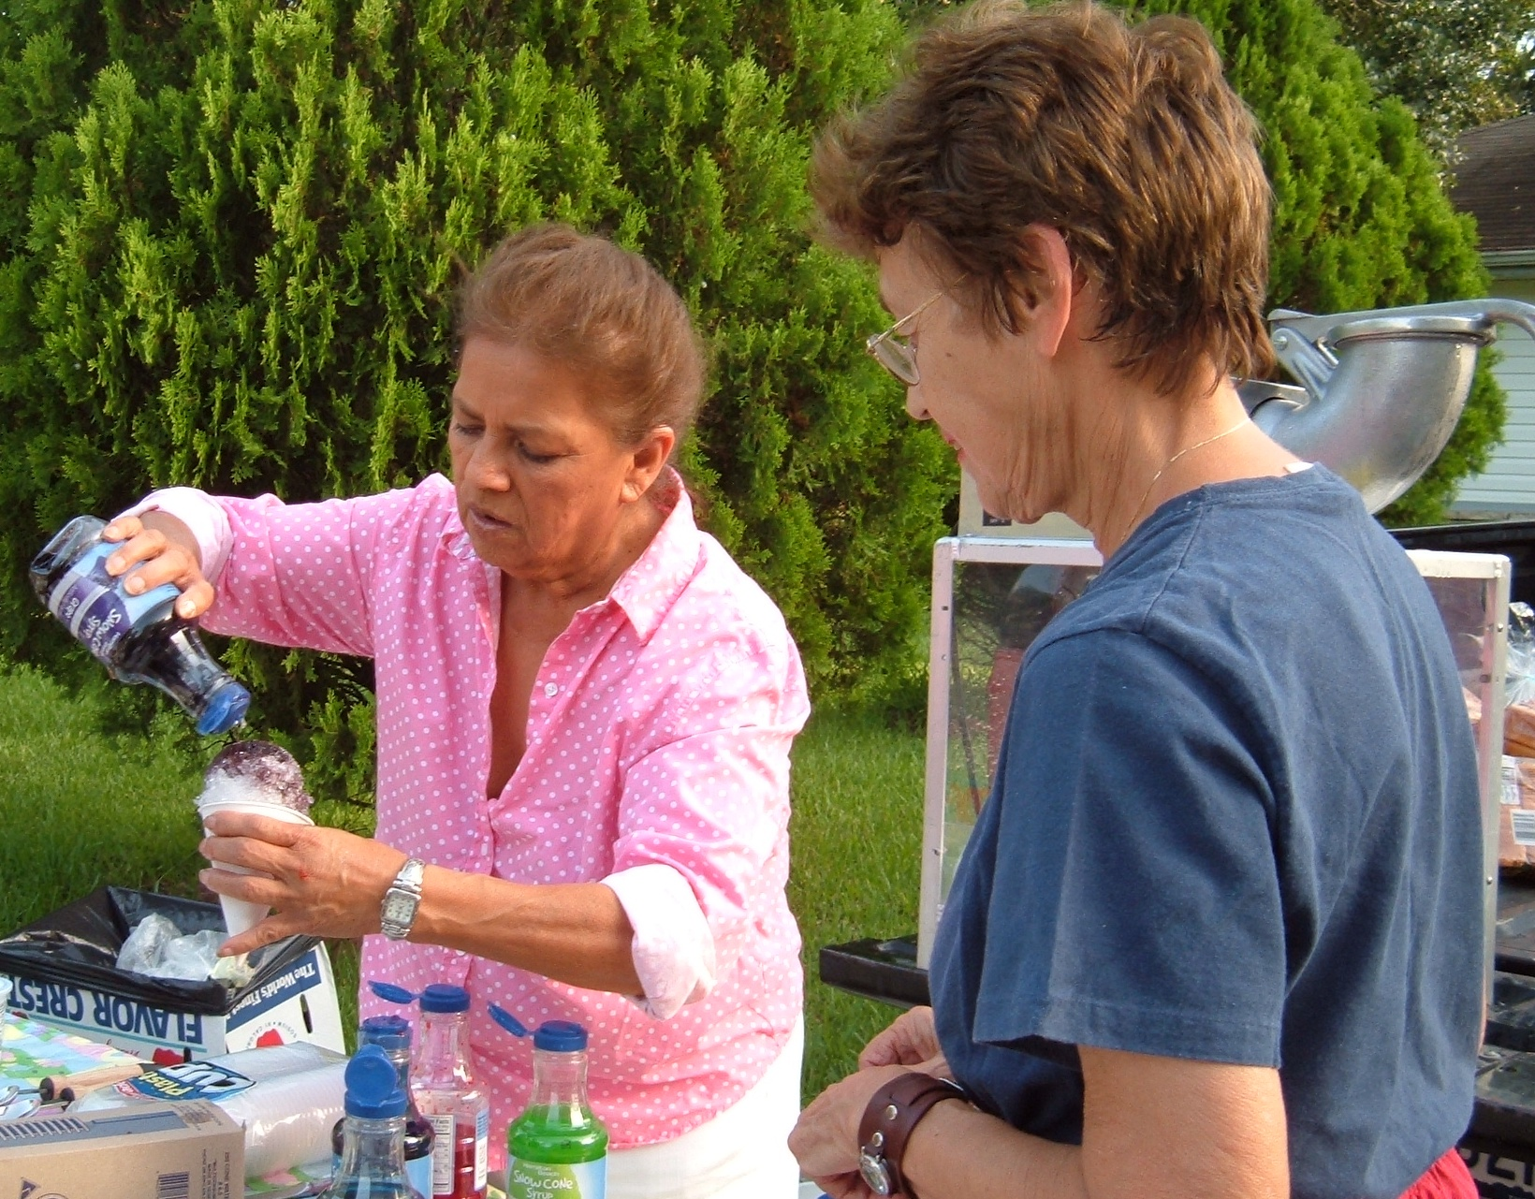

Special thanks to Ruth and Dan Picazo, Kitty Myers, Mary McGuire, Marisa Roda, Gloria Galvan, Barbara Ruppert, Lynn and Bob Evans, Elsie Ann Stolzer
and Arturo Romero, who helped plan, serve, cook,
run errands and/or clean up - and to those who
delivered flyers to residents.

We appreciate those of you who brought
home made treats and salads – Joan Brandt,
Joy Swinney, Betty Hickson, Marilyn Hall
and others.

Several local businesses made contributions:

- Wal-Mart Neighborhood Market, who made a major donation of hot dogs, buns, condiments, chips and more
- Happy Lamp Restaurant, Hillcroft
- Little Caesar’s Pizza, Maplewood
- Sound Fitness, Maplewood Mall
- Jack-in-the-Box, Hillcroft
- McDonald’s, Hillcroft
- Beldens, North Braeswood
- Foodarama, Beechnut

NATIONAL NIGHT OUT 2006


